ENC102 – Engineering Design and Sustainable Development

Humanitarian Engineering Design Project Report

Team Name

Team members (including ID numbers)

# Executive summary

This project is about the design of gray water treatment system. The team first collected the basic information of Cape York, learned about the local gray water pollution, and learned basic information about Cape York itself, including economic conditions, environmental sustainability, population, etc. Consider factors. Subsequently, the team analyzed and put forward evaluation indicators for multiple schemes. At the same time, we learned about multiple gray water treatment schemes through references. In these schemes, the group considered: centrifugal filtration dehydration, centrifugal sedimentation dehydration, vacuum filtration dehydration, pressure filtration, Grey water dehydration and other technologies. Immediately afterwards, the team conducted a comprehensive evaluation of all the programs through these indicators. The final solution was reached by considering the project itself and the actual local conditions. The team finally adopted gray water reuse (recycling of water resources, which can effectively solve the gray water treatment problem), plate and frame membrane filtration, and multiple raw materials. Slurry gasification, filter press dehydration treatment, designed a new generation of grey water treatment system

# Introduction

York Cape (York Cape) is located at the northernmost point of the Australian mainland. Located at the northern end of the Cape York Peninsula in Queensland, across the Torres Strait from New Guinea Island. It is about 25 kilometers (15 miles) long and 19 kilometers (12 miles) wide. It was named after the Duke of York, the brother of King George III, by the British navigator Captain Cook in 1770. [1]

In this event, the team studied the gray water treatment project, which aims to solve the thorny problems related to the gray water generated during the camping process in some areas of Cape York. In order to obtain the optimal design plan, the team conducted a special survey on the current tourism situation, local aboriginal culture, climate and environment, travel needs, waste disposal policy and other aspects of the three areas of Cape York, and obtained the following survey information:

## 1.1 Travel Resources:

The scenery and natural environment of Cape York is very charming, with a long history and indigenous culture. The desert exploration on the Cape York Peninsula is a very pleasant thing, which makes tourists linger, and many tourists come here to relax more than once.

Although it is remote, the scenery is beautiful. If you like nature then you must not miss it. There are more than 3,000 species of plants and 321 species of birds, with a total area of ​​more than 14 million hectares. According to statistics, Cape York is ranked 13th in Australia's "What You Must Do in Australia Before You Die" list. This is one of Australia's last great natural areas.

In addition to the pristine natural scenery, the indigenous history here can be traced back tens of thousands of years. At the time of the European invasion, the area was composed of 43 tribal countries, each with its own language and traditional customs. Although many dialects are now lost, there are still people who speak indigenous languages ​​in the Cape.

Such beautiful pristine natural landscape and long-standing aboriginal culture have made Cape York a "haven paradise". Therefore, we should do our best to protect this pure land from pollution. But where there are human activities, sewage will be produced, and Cape York is no exception. Therefore, the team will do its best to treat the gray water in Cape York.

## 1.2 Climate environment:

The Cape York area is located in the tropical climate zone at the northern end of Queensland. It has a tropical monsoon climate with humid summers and relatively dry winters [2]. Slightly polluted gray water, if improperly handled, will easily lead to land salinization and water bloom, and if the lightly polluted gray water is discharged randomly, it will cause the phenomenon of "seed burning". If the heavily polluted grey water is improperly treated with a large number of pathogenic bacteria and parasite eggs, it may cause harm to the environment and human and animal health.

According to the rainfall statistics of Cape York from 1887 to 1955, in the rainy season, on average, more than half of the days in a month will rain and the rainfall is mostly concentrated in 1mm-10mm. It can be seen that if the sewage is not treated effectively in time, but is allowed to be discharged into nature, this will cause greater harm to the land and even the natural environment of Cape York in the rainy season.

## 1.3 Travel requirements:

Taste the remote wilderness on deserted beaches and secluded campsites in unspoiled national parks, experience fishing on the shores of remote rivers in the north of Cape York, enjoy spectacular ocean views and absorb the essence of the sun and moon. You can also come around Bamaga with a guide and enjoy incredible bird watching in an amazing environment.

Most of the tourists here are to escape the bustling urban life, return to nature, enjoy freedom and beauty, and become a part of the vast open space. Due to the development of tourism, the local environment has been under tremendous pressure. In order to make the tourism sustainable development, lower gray water treatment costs and lighter equipment are the original intentions of this project.

### 1.4Indigenous:

For indigenous people, land has many meanings—culture, spirituality, language, law, family, and identity. Everyone does not own land, but treats land as his relatives. People here are given the knowledge and responsibility to take care of their land, with a deep sense of identity, purpose and belonging. This in-depth understanding of the land is also reflected in the language. This deep relationship between people and land is generally referred to as "the connection between the individual and the country."

"Land and people are one, because land is also related," Garp Elder Dangar Guruwivi from Enhulunbuy, Northern Territory, explained. "In our kinship system, as a guardian, I am a child of that land," she said. [3]

The relationship between many indigenous peoples and the land is a relationship of mutual benefit and respect-the land maintains and supports the people, and when the land is destroyed, it will have a real impact on the lives of the indigenous people. The proper handling of grey water will directly affect the quality of the land.

## 1.5 Waste treatment policy:

Queensland's waste management and resource recovery strategy will be supported by a waste treatment tax, providing a strategic framework for Queensland to become a zero-waste society, avoiding waste, reuse and recycling to the maximum extent [4]. This policy supports infrastructure investment in various places to help improve communities’ access to recycling opportunities. This will provide sufficient funds for the project to ensure the smooth implementation of the plan, and enhance communication with local governments and local residents. This will enable This project gained more support and understanding.

# Defining the problem

## Project Objectives:

### Overall objective (AIM)

This project is mainly designed to design gray water treatment equipment models for people traveling and camping in Cape York. While people use them, the gray water can be discharged up to the standard and protect the local natural environment.

This project is mainly designed to design gray water treatment equipment models for people traveling and camping in Cape York. While people use them, the gray water can be discharged up to the standard and protect the local natural environment. The project is designed to desalinate grey water and achieve recycling of water resources. Now that the freshwater resources on the earth are declining, it is necessary to achieve multiple uses of water through gray water treatment and recycling, and the practice site of the project is in a place where fresh water resources are scarce. Designing a gray water treatment system on this site can alleviate the shortage of local fresh water resources. The status quo. What the project is trying to achieve is based on humanitarianism and environmentalism, designing an efficient, convenient, and gray water treatment system for local residents and tourists.

### Target planning (TARGET):

1. Analyze the climatic conditions of Cape York to design a gray water treatment equipment model to understand the local gray water discharge standards, and strive to make the gray water recycled and discharge up to the standard.

2. Establish a comprehensive analysis model based on the indigenous and tourist culture of the water area, so that the design meets the local humanistic needs. ；

3. According to the different harmful materials contained in the grey water, complete the design of diversified grey water treatment schemes;

4. Investigate the local products and output of Cape York, so that the construction and post-maintenance of the project can be integrated into the local community.

## 2.2 Design standards:

### 2.2.1 General overview

According to the standards of the sewage treatment system required according to the humanistic standards. Adhering to the belief of not damaging the natural environment and the human environment, these standards are formulated in accordance with the requirements of international regulations.

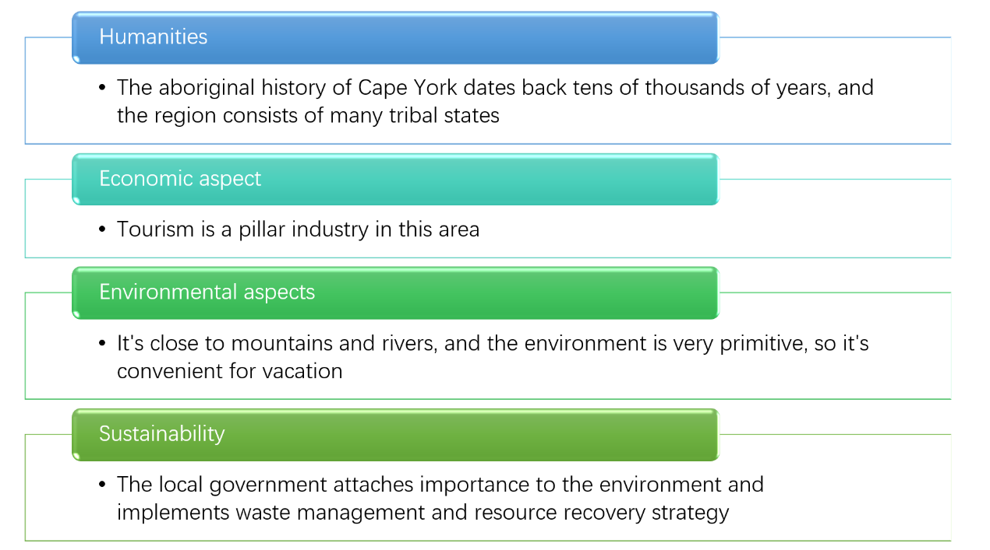

Figure1 Four factors that the project must consider

### 2.2.2 Design background description analysis:

Through the survey of relevant data, （Table1 ）the following figure shows that the overall development of Cape York is still relatively good, the area is not small, which is conducive to the development of the gray water treatment system, and the local economic conditions are considerable, the transportation is convenient, and the climate is suitable. There are abundant tourism resources, and a large number of tourists will come to travel during the tourist season, and a large amount of gray water will be produced. Therefore, our gray water treatment system is suitable for the specific local conditions.

Table 1 Socio-economic situation in Cork York

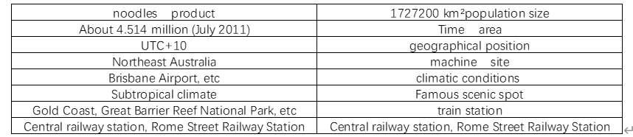

It is easy to know from the Table2 that in the rainy season, on average, more than half of the days in a month will rain and the rainfall is mostly concentrated in 1mm-10mm. It can be seen that if gray water is not treated in time and effectively, but is allowed to be discharged into nature, this will cause great harm to the land and even the natural environment in Cape York during the rainy season. Therefore, the development of a gray water treatment system in Cape York is necessary.

Table2 Monthly climate statistics

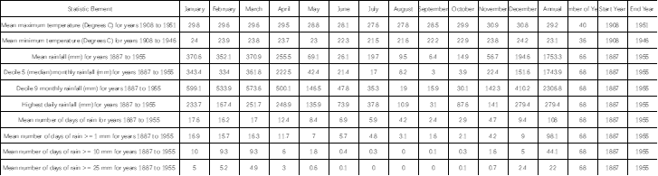

### 2.2.3 Importance setting:

These standards are formulated based on humanistic standards and taking environmental factors into consideration. The development of these standards will not only make the designed grey water treatment system more convenient and effective to use, but will also benefit stakeholders and the protection of the environment.

Table3 Proportion setting of each factor

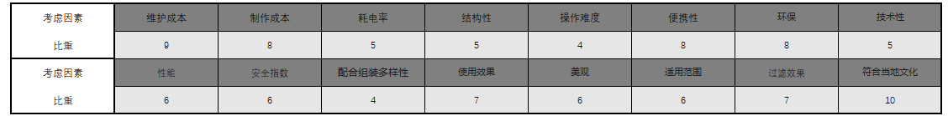

1. **Maintenance cost, production cost, power consumption rate:** Considering that most of the residents living in the Cape York Peninsula are indigenous people and their economic level is limited; tourists who travel to the local area also hope to enjoy more preferential consumption; campers have special expenses during the camping process. The environmental conditions do not have sufficient power and other resources, and the gray water treatment equipment needs to be maintained from time to time.
2. **Structure, difficulty of operation, portability:** According to the analysis of different groups of people, most of the gray water in the Cape York Peninsula comes from the residents who live in the local area. These residents will continuously produce gray water in the kitchen, bathroom, etc., so If the gray water is to be disposed of in time, the equipment is required to be easy to operate for the public.
3. **Environmental protection:** With the rapid development of science and technology around the world, the natural ecological balance has been violently impacted and destroyed, and resources are decreasing. Therefore, as far as the current situation is concerned, whether it is to explore and solve any problems is based on environmental protection.
4. **Technical:** Technical performance should be adjusted as it is applied to different regions and facing different people. Based on the special populations of the indigenous people, tourists and some camping teams of the Cape York
5. **Performance and safety index:** Whether the performance is stable and whether the safety index is high will affect the operation, maintenance and use effect. Therefore, performance and safety index are also important humanistic standards.

### 2.2.4 Analysis of the most important factors:

Combining the local development and natural conditions of Cape York, as well as the needs of tourists themselves. Adhering to the requirements of humanism, and comparing and analyzing the weights of mathematical knowledge, we can see that in the design standards, environmental protection, portability, maintenance costs, and production costs account for the largest proportions, and conform to the local culture accounted for the strongest proportions. The low production cost is taken as the objective function, and the local cultural acceptance is taken into consideration to obtain the lowest cost and the best design plan.

# Design options

## General overview

At this stage, there are mainly the following methods to treat gray water in the world: **plate and frame membrane filtration, vacuum belt filtration, flocculation and sand filtration treatment, constructed wetland filtration, multi-slurry gasification, adsorption filtration, and dehydration treatment.**

The dehydration treatment includes: **centrifugal filtration dehydration, centrifugal sedimentation dehydration, vacuum filtration dehydration, pressure filtration, gray water dehydration and other technologies.** The following is an evaluation of the above 5 methods and the 5 seed methods of the fifth method:

## 3.2 Program introduction and evaluation:

### 3.2.1 Plate and frame membrane filtration

This kind of equipment is simple in structure, easy to replace, and it also has strong sustainable development characteristics. Its main advantage is that it can significantly reduce the water content of the filter cake and meet the increasingly stringent environmental protection requirements. At the same time, the plate and frame membrane filter has disadvantages:

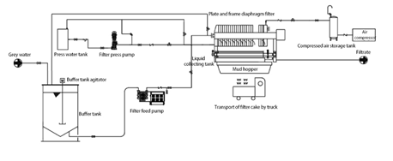

Figure 2 Plate and frame diaphragm filter [5]

1. There are certain requirements for the viscosity of the filter cake. In the gray water treatment device, the viscosity of the filter cake is not large, and the filter cake is easier to separate; for the filter cake with higher viscosity, it is easy to stick to the filter cloth and cause automatic separation. , Requires manual processing;
2. Frame-type membrane filters are rarely used in gray water treatment devices, and there are not many practical experiences. Therefore, when selecting a filter for the gray water treatment device, it is necessary to comprehensively consider the cost, material characteristics, technical requirements and other aspects.
3. At the same time, the plate and frame membrane filter on the market has a larger structure. The overall energy consumption level is relatively high.

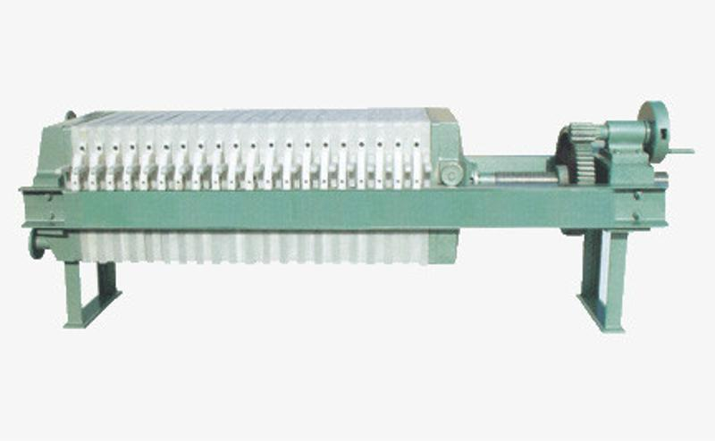

Figure 3 Picture of Plate and Frame Membrane Filter [6]

In this project, the design only considers the functional realization part.

The internal schematic diagram is shown in the figure:

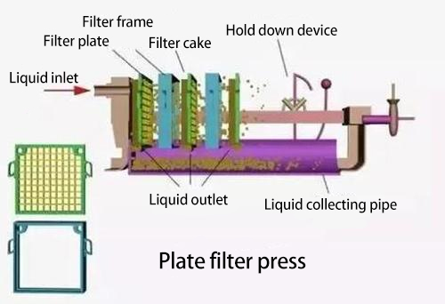

Figure 4 Internal structure of plate and frame membrane filter

### 3.2.2 Vacuum belt filter

The vacuum belt filter is a new type of filtration equipment with a high degree of automation. The machine uses filter cloth or filter screen as the medium to make the slurry horizontally arranged on the filter medium, making full use of the slurry gravity and vacuum suction to achieve solid-liquid separation . The continuous horizontal belt vacuum filter can be applied to materials under a variety of concentration conditions and has high filtration efficiency, so it is preferentially adopted by the heavy industry.

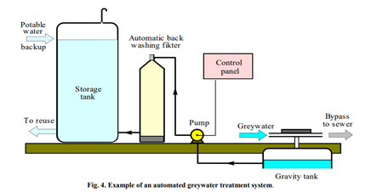

Figure 5 Internal structure of vacuum belt filter [6]

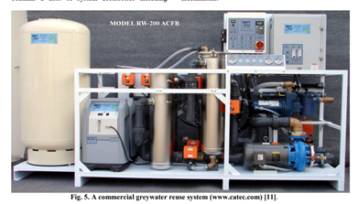

Figure 6 Illustration of vacuum belt filter [6]

As industrial filtration equipment. Its overall size is relatively large, energy consumption is relatively high, purchase cost and maintenance cost are at the highest point in the plan.

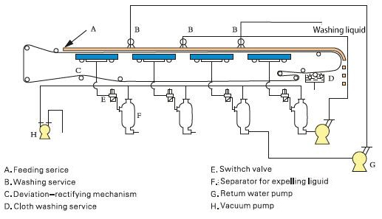

Figure 7 Internal structure of vacuum belt filter

In addition, as shown in the figure, its technology is more complicated, involving multiple components and functions. The vacuum treatment also involves high-quality steel and advanced monitoring technology, and overall it is not suitable for downsizing and civilianization.

### 3.2.3 Flocculation and sand filtration treatment

Ordinary flocculation and sand filtration are not ideal for the treatment of grey water. However, the addition of activated carbon can achieve a better treatment effect. The treatment results of the combined process of flocculation, sand filtration and granular activated carbon show that the removal rate of COD is as high as 93%, and the removal rate of BOD5 and anionic surfactants is as high as 95% . Research on the grey water pretreated by ultrafiltration UF and then treated by reverse osmosis RO process shows that the removal rates of COD, BOD5 and grease are as high as 98.9%, 99.2%, and 75%, respectively. [7]

The specific function realization principle is shown in the figure:

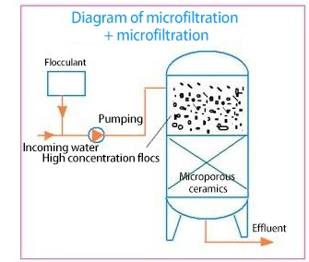

Figure 8 Illustration of the structure of flocculation and sand filtration treatment

### 3.2.4 Constructed wetland filtration

Constructed wetland filtration has become the first choice for grey water treatment process due to its low cost

However, if the portability is increased, the weight of the entire device will inevitably increase. As shown in the figure, the device must contain a variety of pebbles. gravel. Moreover, the filtering speed is slow. Although its structure is simple and easy to manufacture, its filtering efficiency cannot meet the basic needs of campers.

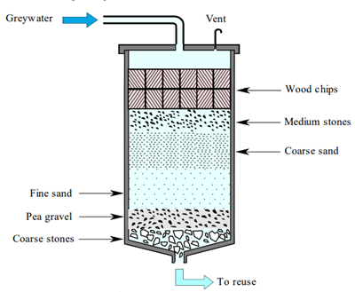

Figure 9 Diagram of Filter Structure of Constructed Wetland [6]

### 3.2.5 Adsorption filtration method

Adsorption treatment is a water treatment process that uses porous solid materials to absorb and separate pollutants in water. The solid matter that absorbs and separates pollutants in the water is called an adsorbent. Adsorbents include: activated carbon, activated coal, coke, cinder, resin, wood chips, etc.

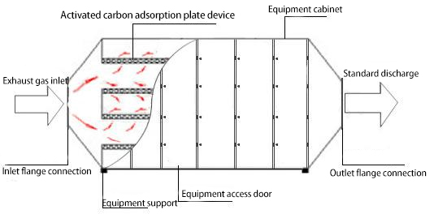

Figure 10 Structure diagram of adsorption filtration method

The overall technology content is low, the application and manufacturing are simple, and it is suitable for preliminary treatment of gray water.

### 3.2.6 Dehydration treatment

# Evaluatee (or selection of final design)

## Model design concept evaluation

Combined with the Design Criteria of the project, the specific weight evaluation of the model is carried out, and the following table is obtained:

Table 4 Specific weight evaluation form

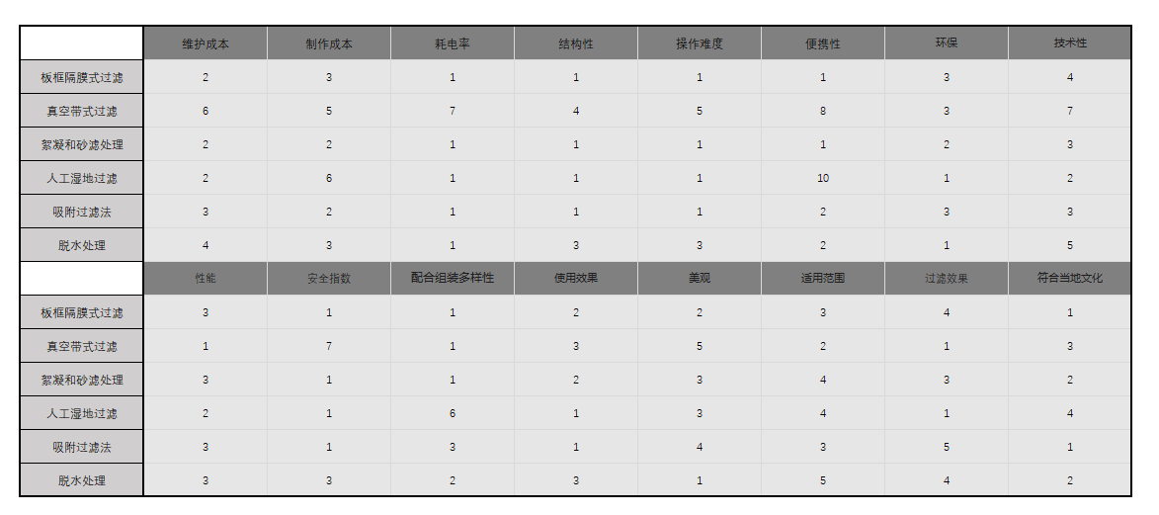

It can be seen from the ranking table of the design standard proportions of different models that, in summary, the plate and frame membrane filter is relatively strong in environmental protection, production cost, and weak in portability. The dehydration treatment method is easy to replace and practical. Strong, good filtration effect by adsorption filtration method, easy operation and low production cost. In summary, plate and frame membrane filtration and multi-material slurry gasification, as well as dehydration treatment and adsorption filtration methods are used at the same time. These four schemes are the best methods for the treatment of grey water in the above several schemes.

Among the several schemes in the dehydration treatment, we carried out specific weight evaluations to obtain the following table:

Table5 Specific weight evaluation form.

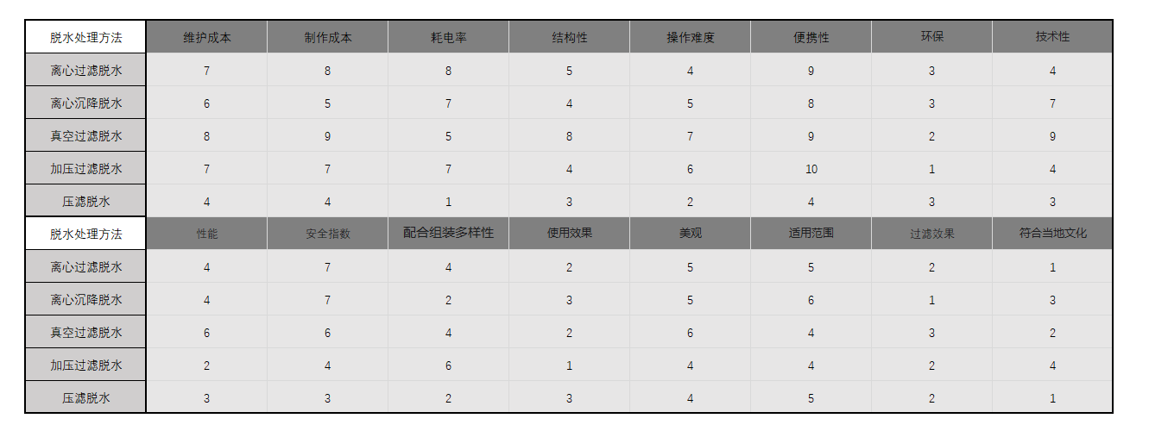

Analysis: Filter press dehydration and filter press dehydration have better effects. However, pressure filtration technology is more difficult and will significantly increase the overall project cost. Therefore, we believe that filter press dehydration is the best gray water dehydration treatment program.

## SWOT diagram

Based on the economic and environmental conditions of Cape York, we conducted an overall assessment of all the models built in the project and obtained the following SWOT diagrams of the advantages and disadvantages of the models:

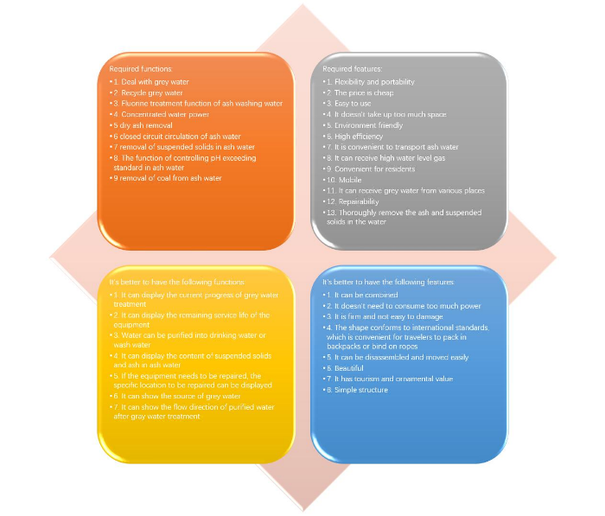

Figure11 SWOT analysis diagram of features to be considered

**（1）Cooperate with assembling diversity:** for the applicable people of this project, for different use locations and different degrees of gray water treatment. The equipment is required to be diversified and assembled according to different situations in order to be suitable for various environments.

**（2）Use effect, beautiful appearance, and scope of application:** Technical performance and use effect are rigid indicators that a device must achieve. But with the improvement of living standards, people's requirements for spiritual life are increasing day by day. Not only the pursuit of high-quality products, but also stricter appearance requirements.

**(3)Filtration effect:** The ultimate goal of this project is to effectively treat gray water, treat and reuse light gray water, and treat and discharge heavy gray water.

**(4)Conforms to local cultural customs:** The gray water treatment system is designed and operated in Cape York, so our design concepts and design factors must conform to local cultural customs, so that the designed gray water treatment system can really be invested Go to the production and life of local residents. In human-centered engineering design, this is the most important

## evaluation result

After evaluating and predicting the model according to the design criteria, the above pie chart is obtained. It can be concluded that: frame membrane filtration, multi-material slurry gasification, filter press dehydration, and adsorption filtration process account for the same proportions, and they all occupy the main position. Therefore, we invest and process these four methods There are also more, these four items occupy the main position of our design, and other aspects have relatively little impact on the gray water treatment device, so our investment in this device is relatively scientific.

# Design considerations and Evaluation of the final design

## Final design

### Function overview

Our equipment mainly treats gray water through three methods: gray water reuse, plate and frame membrane filtration, multi-material slurry gasification, and filter press dehydration treatment.

We first divide the ash water into two types of gray water according to the degree of recyclability of the gray water. Then we adopted different design methods for light gray water and heavy gray water. For mild gray water, we adopt the adsorption filtration method to directly recycle the gray water for reuse. For the deep gray water, we first use the plate and frame membrane filter press method for preliminary filtration, and then perform deep filtration and solid-liquid separation of the gray water through filter press dehydration treatment and multi-material slurry gasification. Discharge the separated clean water to nature, and collect the separated solid residue.

### Definition of light gray water and heavy gray water:

Generally speaking, kitchen water and flushing water are heavy gray water, and the others are light gray water. Gray water should be composed of bath water, laundry water and kitchen water in the household indoor water. However, because kitchen water and flushing water contain a certain amount of food residue, oil and fat, the organic matter content is high, and it needs to be filtered and reused. Necessary special treatment. Therefore, we classify ash moisture into two categories.

### Light gray water treatment

For light gray water, we adopt the adsorption filtration method to directly recycle the gray water.

Color and turbidity are important indicators of reused water. The treatment of turbidity is mainly through filters to filter impurities, and the treatment of chroma is mainly through chemical treatment and physical adsorption.

Chemical treatment needs to adjust the gray water to alkaline, add a proportion of decolorizing agent to make the gray water form a flocculent sediment, and then separate and filter to obtain the reuse water. Before mixing, the water quality and water quantity must be accurately controlled, otherwise it will cause decolorization failure. This program is suitable for decolorization of large gray water or sewage ponds. Physical adsorption mainly relies on the adsorption effect of activated carbon. Activated carbon can effectively adsorb colored substances, decolor and deodorize. The disadvantage is that the adsorption is saturated and requires regular cleaning and replacement. Comprehensive analysis of the use environment and the quality of the grey water investigated, the grey water treatment plan is determined as follows: filter cotton for turbidity treatment, activated carbon for physical adsorption, decolorization and deodorization.

**Grey water reuse process:**

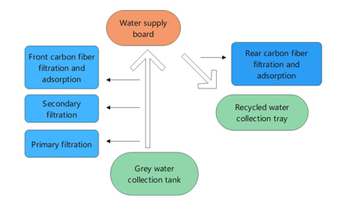

Figure 12 Grey water reuse process

**The working principle of the gray water reuse system:**

The gray water in the gray water collection tank is filtered and adsorbed through the treatment devices at all levels through the suction and lift of the pump (in the design, we use natural gravity to fall, no need to apply a water pump) to form a return The water is stored in the middle water tank, and finally flows into the toilet water booster for daily toilet flushing to realize the reuse of gray water. After filtering the gray water in the gray water collection tank, a certain amount of solid impurities will remain, and the impurities will enter the dirt tank through pressure or vacuum. When the gray water is available, switch to gray water at the first time. When the amount of water in the gray water collection tank is insufficient, the pipeline between the intermediate water tank and the toilet water booster is closed. At this time, the water in the clean water tank Clean water will be directly injected into the toilet water booster to ensure that the toilet has enough water for flushing.

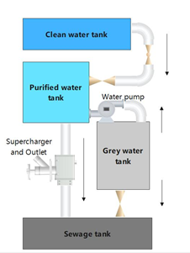

Figure 13 Grey water reuse process

### Severe grey water treatment:

First, we use the plate-and-frame membrane filter press method to initially filter the gray water.

The process description of the plate and frame diaphragm filter in the gray water treatment device The working process of the plate and frame diaphragm filter usually has five steps in the entire solid-liquid separation device:

1 Material filtration,

2 Pressing of filter cake,

3 The filter blows back,

4 unloading

5 Cleaning of filter cloth.

### Feature design

The whole machine has two modes:

**Grey water reuse mode:** This mode can handle mild grey water. The grey water can be recycled.

**Gray water discharge mode:** This mode can filter and discharge the gray water that is really unusable.

1. First of all, the gray water is filtered: plate and frame membrane filtration to remove impurities.
2. Subsequently, the gray water is dehydrated, and the obtained water is reused as gray water, and the remaining part of the deeply polluted gray water is deeply filtered.
3. The final deep filtration and the use of raw material slurry gas method. Through the degassing tank. Reduce the oxygen content of the treated water to avoid the breeding of blooms and other pollution. After treatment, the treated water can be discharged into nature.

### 3D model

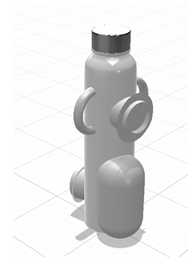

Figure14 3D model picture of the device

The whole equipment includes the whole bottled. Contains three interfaces. Interface 1 is at the top. Port 2 is located on the upper side. Among the two interfaces, interface 1 is a heavy gray water treatment interface, and interface 2 is a light gray water treatment interface. The interface 3 is the grey water discharge port after treatment and the discharge port of the liquid after the grey water reuse.

The whole device is 60cm high. The radius of the middle cylinder is 20cm. The weight is 1kg. Can purify gray water per hour: 1.5L. The entire device does not consume power. The parts that need to be replaced include: frame diaphragm. Filter press, activated carbon membrane. Among them, the frame diaphragm and pressure filter can be used in the market to treat more than 1000L of water at a time. The activated carbon membrane can treat 20L of water at a time and has degradable components.

## 5.2 Design Considerations

### 5.2.1 Sustainability of design

(1) For the sustainability of environmental protection, the team’s design is particularly prominent in the protection of water sources. The team’s design can purify the gray water produced and then discharge it, minimizing the impact of sewage on the environment. The purified water can be recycled again to achieve sustainability. In addition, this project is also particularly important for soil protection. If the gray water is not purified and discharged, combined with the local environment, it is extremely easy to cause water enrichment. This project will work to solve such problems. The classification and purification of grey water and then discharge will greatly reduce the harm to grey water soil, and can play a role in improving soil nutrients. In addition, the water purified by this project can be used for irrigation and toilet flushing in other places besides drinking water, which has made a significant contribution to saving water resources.

(2) For the sustainability of the device, the filter system in the device can be replaced and cleaned regularly, the working condition of the device can be checked regularly, and the purified water can be inspected from time to time. At the same time, the parts of the entire device are also It is highly replaceable. In this regard, the project will organize training for some local suitable candidates to enable them to be able to perform equipment repairs and maintenance, effectively prolonging the use time of the equipment. And the equipment uses local materials as much as possible, and the replacement and maintenance of equipment will no longer be cumbersome. And the parts of the equipment use low-priced materials as much as possible, allowing users to pay and be willing to pay for maintenance.

(3) For the continuity of the operation of the project, the project is invested and constructed by the government and non-governmental organizations. In the later use, it can be collected from tourists by lease or tax. While increasing fiscal revenue, local organizations have the enthusiasm to maintain equipment and avoid equipment idleness and waste. While protecting the environment, it also enhances tourists' awareness of local characteristics. While enjoying the beautiful scenery, tourists also know that the scenery is hard-won and will cherish it better, thereby enhancing their environmental awareness.

### 5.2.2 Impact on community

The scenery and natural environment of Cape York is very charming, with a long history and indigenous culture. Desert exploration on the Cape York Peninsula is a very pleasant thing. There are more than 3000 kinds of plants and 321 species of birds, with a total area of ​​more than 14 million hectares. According to statistics, Cape York is ranked 13th in Australia's "What You Must Do in Australia Before You Die" list. This is one of Australia's last great natural areas. Millions of tourists come here for adventure every year. In this process, the discharge of gray water cannot be effectively controlled.

At the same time, the relationship between many local indigenous people and the land is a relationship of mutual benefit and respect-the land maintains and supports the people. When the land is destroyed, it will have a real impact on the lives of the indigenous people. The proper handling of grey water will directly affect the quality of the land.

The project can process the gray water produced in the community and the area and its surrounding areas, play a role in the recycling of water resources, achieve the purpose of environmental protection, make the community environment better, and the lives of community residents more Convenient, while benefiting community residents, developers, builders and designers to varying degrees.

The design of the cover project can also deal with the grey water produced by travelers camping in the wild. By filtering the grey water they produce, reducing the discharge of grey water in nature can ensure the health of the local soil and the ecological environment. Conducive to local land protection, making the community environment more tidy.

In addition, this technology can also improve local technical capabilities and sell the equipment to people traveling. And provide after-sales maintenance services to drive local economic development.

### 5.2.3 Cultural and social factors

When designing the project, we will give priority to the connection and influence of the project we design with local culture, environment and other factors.

There are huge differences between countries and ethnic groups. Religious customs, ethnic habits, economic models, and industrial structures are all different, and their demands for dealing with losses are also different. If we blindly advance the project based on our needs and ideas, we will inevitably encounter difficulties and setbacks, arouse the resentment of local residents, and cause difficulties in cooperation. Therefore, before developing the project, it is necessary to carefully consider the local religious and cultural living habits and not make mistakes on the most basic issues.

We learned about the local culture and customs before designing. The initial plan of the program is to have the research team deeply understand the people's conditions, improve the integration and practicality of the project, and reduce the sense of rejection. It is hoped that this approach can narrow the distance between the project and the government and residents. In designing the appearance of the equipment, we will also look for solutions while considering the wishes of the local owners. Only based on these comprehensive ideas can the residents accept and like the design more.

According to initial investigations, for many aborigines in Australia, land is much more than soil, rocks or minerals. This is a way for a person to communicate with nature, and the locals have a special belief in the land. Before colonization, the reciprocal relationship between people and the land supported all other aspects of the lives of indigenous peoples. Today, this relationship with the land is still the foundation of the identity and way of life of many indigenous peoples. Therefore, the original intention of this project is to protect the environment and occupy as little land as possible. We will conduct friendly communication with local residents, inform them of the advantages and benefits of this project, and ensure that every inch of land will be used well and will not cause damage to the land or any disrespectful behavior. In addition, the local elders or scholars are invited to lead and supervise, and earnestly fulfill their promises.

Our design can process the gray water generated by the residents of the community, which will affect the residents' awareness of environmental protection, thereby affecting the entire community environment, making the community environment cleaner and tidy. And we can design and perfect the project with the concept of humanism. This will also have a certain impact on the cultural customs of the community, will improve the quality of residents, and make people's lives cleaner and sanitary.

This project will invite the "Reconciliation Australia" organization to participate, and we will have a deeper understanding of the local culture. The vision of this organization is to build an Australia that recognizes and respects the special status, culture, rights and contributions of Aboriginal and Torres Strait Islander people. Therefore, if there is any misunderstanding between this project and local residents, we will cooperate with this organization to jointly promote the smooth progress of the project.

### 5.2.4 Community engagement

**(1) Overview**

Community participation is very important in humanitarian engineering projects. The service objects of this project are mainly for the community and campers, so this project needs to ensure that the things we design meet their needs. We need to understand the needs of the community in order to determine which aspects of our project will be specifically addressed, and communicate with the government and non-governmental organizations to clarify what can be achieved by this project. We can involve stakeholders such as communities, governments, and non-governmental organizations in project scope definition, initial design, implementation stage, and post-maintenance, so that the project can achieve the final desired effect efficiently.

**(2) Scoping stage**

* Have good communication with local indigenous people to ensure respect for the land during the implementation of this project
* Adhere to the important principle of adapting measures to local conditions and design this project in combination with local climate and topographical conditions to ensure that the project can be carried out smoothly in the local area
* Communicate with the local government to clarify budgets and policies, communicate with local non-governmental volunteer organizations, seek help, and seek more possibilities for the development of the project
* Communicate with local suppliers to check which materials can be localized and low-cost, and seek long-term and stable cooperation

**(3) Initial design stage**

* Establish an expert team to collect and evaluate data on the local climate environment, geographical topography, and various types of gray water discharge of residents, and make specific implementation plans for residents who intend to install gray water treatment systems, based on the type of gray water discharge of each household As well as the uniform adjustment plan of the total discharge amount, select the appropriate gray water treatment system, and try to achieve one-to-one precise service and targeted implementation plans.
* Dispatch professional engineering personnel to form a support team to conduct timely statistics and maintenance of the problems that occur in each household. Let local residents really understand our equipment, through visits, publicity lectures, and experts' imparting knowledge of grey water treatment. Through the results of the treatment, the local residents can better understand the feasibility of the project, and the results of the treatment can show the advantages of the project and summarize the benefits that the residents can obtain. Do a good job in the ideological work of local residents and the government.
* Negotiate the specific construction time, construction location, and construction related personnel with the government and civil organizations, and confirm the issue of project support funds
* Conduct project bidding, select the best solution, the most economical raw material supply plan, and the most effective labor plan
* Carry out factory site selection. Consider the optimal location factor. Determine the factory address.

**(4) Implementation stage**

We apply the grey water treatment system to real community life and allow the community to provide real feedback and opinions, which will be conducive to the improvement and perfection of our project.

1. Organize local people to distribute survey questionnaires around the base. Understand the actual needs of campers.
2. Negotiate funds with local government departments and communicate with the government in time when construction difficulties arise
3. Invite a group of local community residents to participate in the construction of the project, so that they can truly feel the benefits of the project to their surroundings, so as to calm the residents' minds.
4. Put part of the profit of the factory into local infrastructure construction and environmental protection.

**(5) Post-maintenance**

1. Cultivate a part of the local community residents so that they have the corresponding maintenance technology.
2. Long-term cooperation with local material suppliers for customization and long-term supply of equipment consumables
3. Cooperate with local governments and non-governmental organizations to provide a certain amount of funds to support equipment maintenance costs

### 5.2.5 Environment

We considered the positive and negative impacts on the environment while designing.

1. **The positive impact of the design on the environment:**

This table shows the harmful substances (water composition) contained in the waste water after each use

Table 6 Composition in grey water

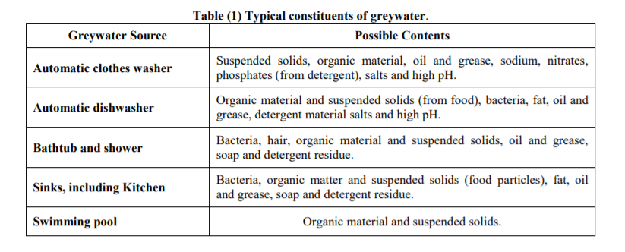

It can be known from the table that gray water contains a variety of harmful components. As described in the previous regulations, these harmful ingredients will cause serious damage to the natural environment and further harm farmland and people's normal lives.

Grey water treatment removes unwanted suspended or harmful substances from the collected grey water and disinfects it so that it can be used for toilet flushing or irrigation or discharged to the sewer in accordance with local applicable laws. Protect the local soil and environment. At the same time, the grey water treatment system can turn grey water into a recyclable water source, which is an effective use of resources and can gradually enhance the environmental awareness of local residents.

And through the localization of gray water equipment manufacturing, it can also increase local income and increase their attention to environmentally friendly products, and part of the factory’s profits will be invested in environmental protection, and the other part will be invested in the next generation of gray water. Research and development of processing equipment.

1. **The negative impact of design on the environment:**

Regardless of the equipment, due to the obvious industrialization characteristics of the equipment, during the localized production of the equipment, it needs to have a certain area for production, which takes up part of the local land resources and damages the local environment.

In addition, gray water treatment equipment may leak untreated gray water, and the direct discharge of gray water into the environment is harmful to the environment.

### 5.2.6 Cost and economic benefit

**(1) Project implementation cost**

The initial cost includes the initial construction cost of the project, including background investigation, feedback collection, and equipment model construction. Design improvements, trial experiments. Project commissioning, factory site selection, technical training and other costs. Therefore, the maintenance cost is higher than that of the later period.

1. Team transportation cost: 10,000 RMB
2. The team conducts field inspections, counts corresponding data, and negotiates with local community residents and indigenous people: RMB 10,000
3. Bidding: 40,000 RMB
4. Negotiate with the local government and request approval of this project: 30,000 RMB

**(2)Material cost (material cost for a piece of equipment)**

Locally provided materials:

Grey water collection box: 100 RMB

Water supply water board: 200 RMB

Recycled water collection tray: 200 RMB

Middle water tank: 100 RMB

Steel shell structure: 600 RMB

Materials purchased from other places:

Frame diaphragm: 200 RMB

Pressure filter: 300 RMB

Activated carbon film: 200 RMB

**(3)Production costs and benefits of equipment commercialization**

Labor cost: 30,000 RMB

Material transportation fee: RMB 5,000

Warehouse management fee: RMB 2,000

Expected to sell for around A$1,000

1. **Industrial equipment cost:**

Assembly workshop 1500 RMB/m2

Tightness tester is expected to be 20,000 RMB

1. **Equipment maintenance costs**

Labor cost for equipment maintenance: 6,000 RMB/year

Material cost for equipment maintenance (estimated): 2,000 RMB/year

Equipment management fee: 2,000 RMB/year

1. **Economic benefits of society**

Ecological value generated by protecting the environment: 100,000 RMB/year

The rent generated by the group to passengers: 60,000 RMB/year/set

Sewage treatment tax paid by local residents to the government: 10,000 RMB/unit

The project materials except for the frame diaphragm. Except for the three components of filter press and activated carbon membrane, the rest are purchased locally, using localized material selection schemes. It is expected to drive the development of goods transportation, steel cutting, engineering parts, plastics and other industries.

1. **The impact of equipment operation on the local area.**

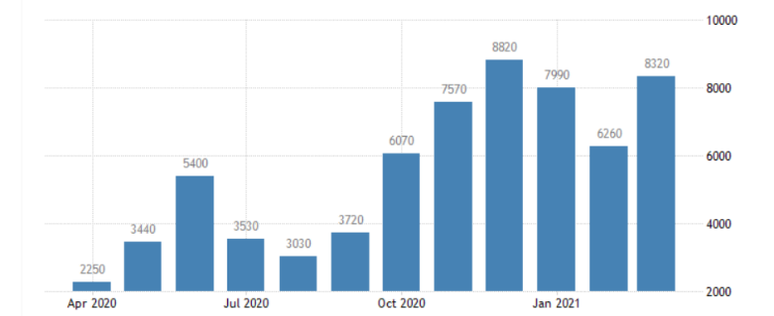

Figure 15 Number of tourists to Australia by year

Which according to the information. In 2019, the number of tourists from abroad alone exceeded one million.

If the project is implemented, it is expected to reach annual sales of more than 10 million Australian dollars throughout Queensland.

Bring huge economic income to the local area, drive local economic development, concentration of manufacturing talents, and the development of related supporting industries.

### 5.2.7 Technical design

The design of this project has a certain regional nature. The entire project is designed with the help of the local natural environment and human factors. During the design process, we will first get familiar with the local topography, cultural traditions and social conditions. Come to optimize and modify design, so the design project is completed for the community, so our design is suitable for the community.

This project takes into account the later maintenance of equipment. When team members withdraw from Cape York, can the production equipment in the factory be maintained to achieve normal operation. At the same time, in order to ensure our product-gray water treatment equipment , Can enable local people to help tourists with paid maintenance. The team specially recorded two videos, the first is about industrial equipment maintenance and equipment repair problems. When the equipment fails, you can scan the QR code to watch the video to achieve self-repair The purpose of this is to save labor costs while ensuring the normal operation of the equipment and maximizing the benefits of the equipment. Another video is about how to repair and replace damaged parts of gray water treatment equipment, and how to do regular inspections.

In addition, all the devices in this project use a detachable modular design. This design is inspired by Apple's Mac pro. Through the fool-like serial number identification of the quick-release modules and the easy-to-disassemble design of each module, the local people can understand the information conveyed by the video easily while watching the video, and this can quickly solve the problem of equipment downtime. , And resume normal work as soon as possible to better protect the environment.

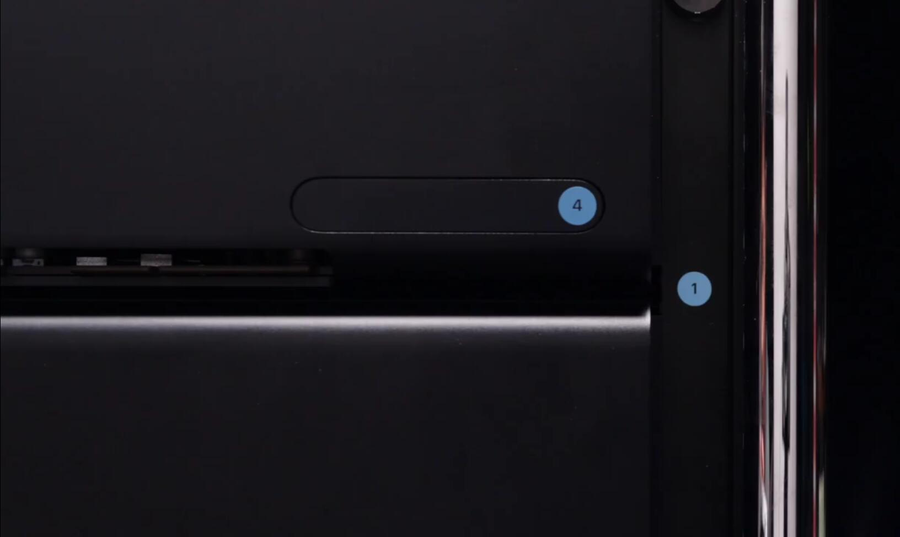

Figure16 Scheme design picture suitable for user operation

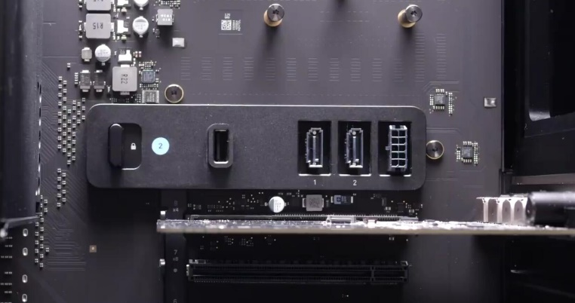

Figure17 User-friendly interface for reference

Finally, the project will cooperate with the local government to train some local community residents as professional equipment maintenance engineers. The local government will allocate special funds to support the salaries of the maintenance engineers and pass on the maintenance technology to ensure that the equipment is within the life of the equipment. The equipment can maximize its value. In addition to the minor problems mentioned above, when the equipment encounters major damage, or the local people cannot solve it after reading the tutorial, it is necessary to send a professionally trained maintenance engineer to provide technical support, and finally ensure the normal operation of the equipment

### 5.2.8 Materials

Most of the design facilities can be obtained locally, and the general framework of the design is set according to the specific conditions of the region. The acquisition of materials can basically be solved locally. Therefore, the design is a design that is adapted to local conditions and suitable for local conditions.

### 5.2.9 Construction/implementation and ongoing operation of the project

**The following are the specific steps to build a design project:**

* 1. Discover the problem: When a group is camping in a field, or a community lives in an area, a certain amount of water will flow out (such as bathing and other activities) and be released into the environment. In order to protect the natural environment from pollution, water treatment equipment is urgently needed, and the cost of grey water ditch is very high. Therefore, this project aims to reduce grey water treatment costs and efficiently treat grey water, which will help to properly manage grey water runoff, thereby avoiding or mitigating any negative environmental impacts.
  2. Empathize with: empathise: After communication and exchange, reach an agreement with the local government and community residents, including indigenous people, and agree to the development of this project.
  3. Investigation and research: Form a team of experts to conduct surveys and interviews with locals, and conduct a questionnaire survey on the team camping here.
  4. Form concept and design project ideate: design the equipment that meets the conditions, design the shape of the project, design the function of the project, and design the operation of the project
  5. Use the designed device for actual operation and display screen: grey water treatment, grey water recovery grey water treatment, grey water recovery
  6. Standardize and rectify: prototype
  7. Compare and discuss the effect after the actual operation with the previous effect: communicate

**Here are the steps required to keep the project running**

1. Carry out practical operation on the designed project
2. Compare the effect of the actual operation with the previous one
3. The influence of conjecture on reality
4. Standardize and rectify
5. Members discuss

**Project need local communities and residents to participate in the design**

1. In cooperation with the community service station, the community staff can help us complete the project better and faster
2. Staff in the community can give us suggestions to improve the project
3. The staff of the community can carry out the actual operation of the project together, give a comparison with the previous effect, and improve the practicality of the project
4. Explain the operation method of our project to the community staff, let the community residents fully believe our equipment, and then get the support of the community residents

**Education and training in the project**

Education or training needs to be provided before designing a project, because whether it is our staff or local community personnel, they all need to understand the design purpose, significance, and design process of the project in detail, which will promote the design of the entire system to be more professional , Teamwork is more effective. For the entire project, education and training are indispensable. Moreover, this can attract some local residents who are interested in this project to participate in the construction of this project.

After the completion of the project, in order to maintain the long-term and stable operation of the equipment, the project will train local residents with professional repair and maintenance capabilities. This part of the maintenance technicians will stick to their posts through the support of government funds and train for future equipment maintenance. Corresponding talents.

# Conclusion

## Main features of the project:

The main characteristics of our design projects are humanism and environmental protection. We designed the project according to the characteristics of high efficiency, aesthetics, environmental protection, humanism and so on. In particular, we uphold the humanitarian spirit and awareness of environmental protection, and design an efficient environmental protection system on the premise of establishing a good cooperative relationship with local residents.

## 6.2 The project meets the criteria:

Our design is based on the design standards to formulate and design the project, which is consistent with the design standards. The projects we design are designed and implemented in accordance with international standards and standards. Therefore, all indicators of the grey water treatment system designed are in compliance with international standards.

## 6.3 Team gains of the project:

By completing this project, we learned how to design a gray water management system that suits the actual situation of a region, which improves our ability to analyze problems. In terms of interacting with local residents, we have established a good cooperative relationship with the community and residents. And when we observe that there are problems such as gray water pollution, we will use existing materials and technologies to solve the problem. And under the condition of not polluting the environment and upholding humanistic standards, we will also treat and recycle gray water. During the entire project period, our team members will discuss and solve problems encountered through communication and other methods, which improves our ability to cooperate and solve problems.

# References

# Appendices

# Appendix A - Gantt char